THE JERK HUB LTD - DISHES AND THEIR ALLERGEN CONTENT

DISHES | 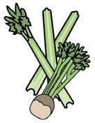 | 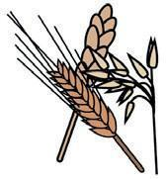 | 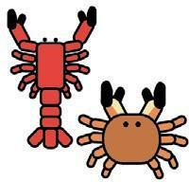 | 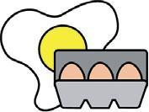 | 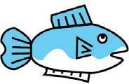 | 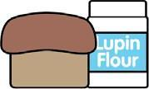 | 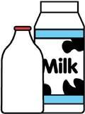 | 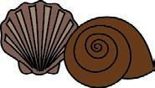 | 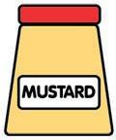 | 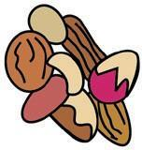 | 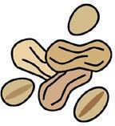 | 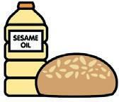 | 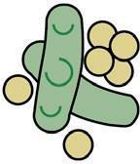
 | Celery | Gluten | Crustaceans | Eggs | Fish | Lupin | Milk | Molluscs | Mustard | Nuts* | Peanuts | Sesame seeds | Soya | Sulphur dioxide
Jerk Chicken |  | ✓ |  |  |  |  |  |  | ✓ |  |  |  |  | ✓
Hennessey Wings |  | ✓ |  | ✓ |  |  |  |  | ✓ |  |  |  |  | ✓
Coleslaw |  |  |  | ✓
Jerk Sauce |  | ✓ |  |  |  |  |  |  | ✓ |  |  |  |  | ✓
Caribbean Salsa
The VITAL Hub Soup (Vegan) |  | ✓ |  |  |  |  |  |  | ✓
White Rice
Rice & Peas |  |  |  |  |  |  |  |  | ✓ |  |  |  |  | ✓
Cajun Fries |  | ✓ |  |  |  |  |  |  | ✓ |  |  |  |  | ✓
Pineapple and Mango Hot Sauce |  | ✓ |  |  |  |  |  |  | ✓
Corn on the Cob
Scotch Bonnet Mayo |  |  |  | ✓
Curry Goat |  | ✓ |  |  |  |  |  |  | ✓
Lemon Pepper WIngs |  | ✓ |  |  |  |  |  |  | ✓

Review date: 2 Apr 2021
Reviewed by: Annette Evans
You can find this template, including more information at www.food.gov.uk/allergy

